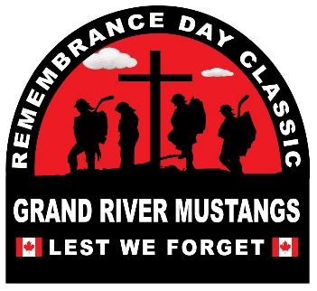
Hello Team Officials,
We are excited to announce that we have reached 58. Thank you for your support!
November 6, 2026
On behalf of the Association, volunteers, parents, and most importantly, the players of Grand River Mustangs Girls Hockey Inc., we welcome you to the 8th Annual Remembrance Day Classic.
This tournament pairs the passion for play with the unique opportunity to honor Canada’s Veterans. It ensures the next generation never forgets those who have served, returned with visible and invisible injuries, and, in many cases, paid the ultimate sacrifice.
We have continued to build on our special partnerships with Royal Canadian Legion Branch 275 Fergus and Branch 229 Elora. We remain thankful for their contributions and support. I encourage everyone to thank a Legion member for their volunteerism anytime you see them in the arenas this weekend.
We hope you will enjoy all that our community has to offer over the weekend. The best part of the weekend will be the renewal of friendships and friendly rivalries. Please cheer loudly with words of encouragement for players from all over Ontario who are enjoying the game they love.
We promise friendly competition and a welcoming environment. There will be lots of activity on our six hockey ice surfaces in Fergus, Elora, Arthur, Palmerston, and Grand Valley to keep everyone entertained. To ensure success, we have partnered with Sportacular Events to bring their years of experience in running tournaments to our Centre.
Join us at our Opening Ceremonies on
Friday in Elora at 11:00AM
Saturday in Fergus at 11:30AM as we welcome the Royal Canadian Legion Honour Guard.
We wish all teams a great weekend of hockey!
See you at the rink,
The Board of Directors, Grand River Mustangs Girls Hockey Inc.

Tournament Information
- Tournament Headquarters: Centre Wellington Sportsplex, Fergus – Main Floor Board Room A.
- 2026 Tournament Schedule: will be available in the Documents Section of the main event page.
- Official Website: https://www2.sportacularevent.com/portal//events/event/122
- (Please do not contact arenas or the city for scores). If you find what you believe as an incorrect score, please notify us via email @ info@sportacularevents.com to help expedite inquiries. Please in subject line use: Game Concern - the division and GM# - then share your concern. Saturday is a very busy day for advancing teams. We have a process which identifies which divisions have to be advanced in a chronological process. Many inquiries are made and the pool or divisions has not completed their final RR games in order for us to calculate and advance teams. We appreciate everyone’s patience.
- Teams Do Not have to register at Headquarters
- Team Ramp Game Codes will be made available once everything is uploaded. The OWHA is still populating divisions in the Tournament link, so please remain patient as teams receive their Final Roster Approvals.

Tournament Vendors
Centre Wellington Arena
- Busy Beads Croc Charms
- Muvwear Official Tournament Apparel
- Lily from Harly Imports & Toys
- Authentic Sports Photography – Team photos, action shots..
- CW sports clothing sale Unity Hall
Designated Warm up Areas:
Sportsplex Fergus: Back gym (Gord Brown Hall) and hall of fame (outside Pad A) open for team warm ups.

Skate Sharpening Info:
Available at Sportsplex: Friday 4:30 pm-7:00 pm, Saturday 9:00 am-5:00 pm and Sunday 1:00 pm – 4:00 pm

Team Roster Submission
AS per Rule #1 of the event;
All Teams will Register at first game by producing your Official OWHA Approved Roster to the Convenor onsite. Hockey Canada and OWHA SUSPENSION rules shall apply where required. Any team using an OWHA Pickup Players must follow these rules of face Forfeiture and or Suspensions and fines. Teams may use the MAX 3 of 3 Players to Replace Existing players on their Official Roster. You can NOT Replace Suspended players. Rep teams may only use Players from below levels of play – No Lateral Callups even if playing up in a combined division. Please note at no time can you NOT exceed the total # of players on your official Roster. The use of an official OWHA Pickup can only be accessed inside your teams RAMP acct, we are no longer are allowed to accept paper versions.
All games will consist of 3 periods (11 minute -11minute-11 minute), stop time with the exception of the U9 division that will play 2 x 23 min periods run time using a 90 Second buzzer shifts. U9 Visitors will change ends at the half.

- Official PDF Rosters MUST be uploaded to your Sportacular Events account.
- Mandatory request for all teams - Log in to your Sportacular Event Acct, go to MY TEAMS, select your registered team, and click EDIT to update your roster and bench staff to ensure correct contact information is correct. Players only require jersey# and name.
- Yes, it needs to be manually typed in for the information below
- Be sure to save your updates to ensure accuracy for game sheets
- A single-page game sheet system WILL BE used for consistency between ice-level officials and administration and RAMP.
- You may now also, as shown where to Upload your teams official PDF roster.

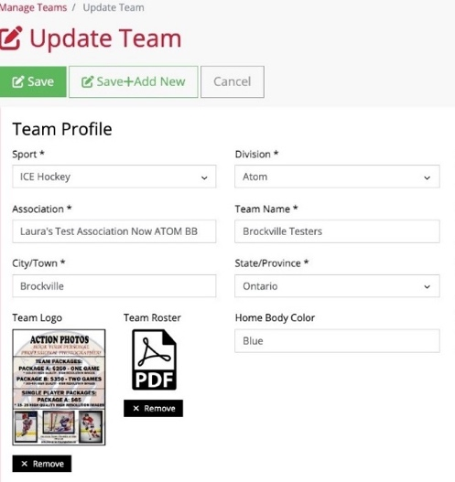
2026 Tournament Updates
- "Soldier of the Game Dog Tag" awards will be given for every game pickup at Arena Convenor Table in lobby you will sign for the award.
- Special Finals Player of the Game award is a commemorate gold medal
- Championship Finals: Winners receive Gold Medals and an Arena Banner; finalists receive Silver Medals.
- New Awards: Same as Player of game awards, if a player has a Hat Trick or Shutout
  - "Wholly Moly Who's That Goalie" Shutout Awards
  - "Holy Hat Trick" Awards for players scoring a hat trick


Important Rules & Reminders
- Player Eligibility: Players can only compete with one team in one tournament during the weekend
- Pickup Players: Any team using an OWHA Pickup Players must follow these rules or face Forfeiture and or Suspensions and fines.
- Any team Found to be using an illegal player or playing suspended players will be removed from the tournament and any further games will results in Game Forfeitures. The OWHA Will also be notified as required
- Rep Teams: Allowed max 3 replacements but cannot replace suspended players. Rep teams may only use Players from below levels of play – No Lateral Callups even if playing up in a combined division. If a team has been found to use an illegal callup or player the team will be removed from the event
ALL Teams cannot exceed their official roster limit at any time.

- Equipment Rules:
- USA Teams: Mandatory mouthguards (per USA Hockey Insurance).
- Canadian Teams: Mandatory BNQ neck guards (per Hockey Canada)
- Suspensions: Hockey Canada and OWHA SUSPENSION rules shall apply where required. All suspensions must be reported to OWHA via email and await their direction as to number of games. You must comply. Clearance must be received before returning to play. Teams from out of Province will be notified of IF a member of team is under suspension
- Travel Permits: All out-of-province teams must submit their travel permits and email to Sportacular Events. If Travel permit is not provided the team is not allowed to play it’s a Hockey Canada Insurance Rule
- Rosters: Have a copy of your roster available in the event of any discrepancy
- Tournament Rules: Posted live on the Sportacular site. Please also note we do not use GF/GA we instead use the Tie Breaker Calculator chart in the document sections.
- Home and Away Jersey Colors Sect 17 of OWHA Handbook
- Home Teams will wear Dark colored Jerseys and visitor teams will wear light.

Game Day Procedures
- Jersey Color Conflicts: Teams should bring an extra set of jerseys or pinnies to avoid conflicts.
- Championship Awards & Photos: Arena banners and medals will be awarded off the ice due to safety and City and Town insurance regulations
- Dressing Rooms:
  - Bring your own lock where required.
  - Keep rooms clean before vacating.
- Game Start Times: Games may begin up to 20 minutes early based on arena convenor coordination
- Check-in Requirements: Team managers or head coaches should check in with arena convenor in lobby before each game. You do not need to check in a headquarters.
- Player of the Game Award: A player of the game DOG TAG will be provided at the sign in table prior to the start of each game and awarded by the coach who will sign for the item
- Shutout/Hatrick Awards: Available at the convenor table at the end of your game
- Identifying Event Staff: Sportacular Event Staff will wear red jackets with “Event Staff on the bank. Ask for help at any game sheet sign-in area
- RAMP Game Codes: Will be emailed and also available at game sheet convenor tables.

2026 TOURNAMENT RULES – COMING SOON
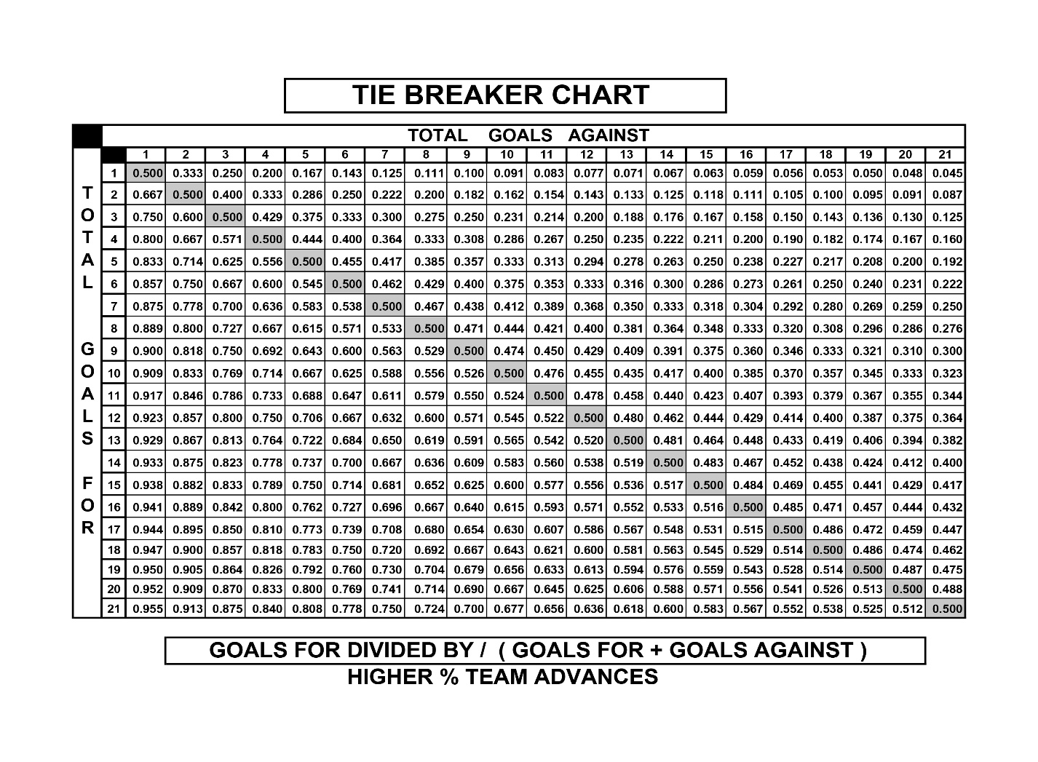
GOOD LUCK TO ALL TEAMS PARTICIPATING IN THIS HISTORIC EVENT!!
**WE RESPECTFULLY ASK FOR YOUR ASSISTANCE IN THAT NO TEAM PHOTOS
BE TAKEN ON ICE DUE TO Municipality & City Insurance Regulations.
*Championship Awards and Medals / Banners
WILL be Presented Off- Ice and will be distributed by coaching as required.
Reminder ALL Suspended Athletes and Bench Staff may not participate in medal presentation ceremonies as per OWHA Rules. We thank you for your anticipated support in this matter.

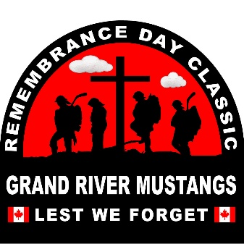 | Grand River Mustangs Remembrance Day Classic  November 7 - November 9, 2025  Elimination, Semi-final, Quarter Finals and Championship games Tournament Rules  OWHA Sanction #2526040
- Elimination, Semi-final, Quarter Finals and Championship games are played to a winner.
- In the event of a tie at the end of regulation time a SUDDEN VICTORY FIVE (5) MINUTE OVERTIME will commence.
- Overtime will be played 4-on-4, plus goalies
  - Any penalties being served at the end of regulation time will carry over to the overtime period.
  - Example 1: If a team is one player short, then overtime will start 4-on-3.
  - Example 2: If a team is 2 players short, they OT will start 5-on-3. On ice strength will be adjusted back to 4-on-4, as per OT rules, at stoppages of play after the penalties expire.
- Clarifications:
  - If a penalty is assessed to one team during the overtime period, play shall resume 4-on-3
  - Should a second penalty be assessed to the same team, play will resume 5-on-3 until the expiry of the first penalty.
  - If the penalty expires during play, the player shall return to the ice and teams will play 5-on-4 until the next stoppage of play, at which point the on-ice strength will be adjusted to 4-on-3, etc.
  - At no time will a team have fewer than 3 skaters (plus goalie) on the ice
- Teams will play 4 on 4 plus goalies. Players may be changed at any time. Goalies may be “pulled” at any time and a substitute player from the bench may be used.
- Penalties do NOT expire at the end of regulation time.
- If still tied, a shoot out will occur.
- Each team MUST designate 3 shooters (S1, S2, S3) on the game sheet BEFORE the start of the game.
- Any player(s) serving a penalty at the end of overtime will not be eligible to participate in the shoot out and MUST remain in the penalty box. The coach must designate a shooter(s) to take her place(s) immediately at the end of regulation time.
- All players except shooter and goalies will be on the bench TO START.
- Shooters from both teams will shoot at the same time starting at the centre ice red line.
- Once a player has shot, they will go directly to the penalty box.
- This is a BEST OF 3 Shootout.
- If still tied, each team will designate one shooter at a time until there is a winner.
- A player may not shoot for a second time until all players on the game sheet signed (except goalies) have shot.
- A penalty assessed in regular time will carry forward to the overtime period. Therefore, the player will not come out of the box.
**WE RESPECTFULLY ASK FOR YOUR ASSISTANCE IN THAT NO TEAM PHOTOS
BE TAKEN ON ICE DUE TO Municipality & City Insurance Regulations.
*Championship Awards and Medals / Banners
WILL be Presented Off- Ice and will be distributed by coaching as required.
Reminder ALL Suspended Athletes and Bench Staff may not participate in medal presentation ceremonies as per OWHA Rules. We thank you for your anticipated support in this matter.

